9. THE MAKING OF REGIONAL CULTURES
TEXTUAL QUESTIONS
1. Match the following:
Anantavarman | Kerala
Jagannatha | Bengal
Mahodayapuram | Orissa
Lilatilakam | Kangra
Mangalakavya | Puri
Miniature | Kerala
Answer:
Anantavarman | Orissa
Jagannatha | Puri
Mahodayapuram | Kerala
Lilatilakam | Kerala
Mangalakavya | Bengal
Miniature | Kangra

2. What is Manipravalam? Name a book written in that language.
- Manipravalam is a language. The book written in that language is Lilatilakam.
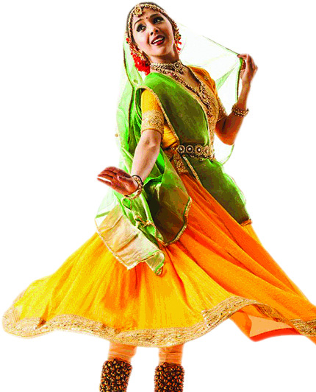
3. Who were the major patrons of Kathak?
A. i. Kathak began evolving into a distinct mode of dance in the fifteenth and sixteenth centuries with the spread of the bhakti movement.
ii. The legends of Radha-Krishna were enacted in folk plays called rasa lila, which combined folk dance with the basic gestures of the kathak story-tellers.
iii. Under the Mughal emperors and their nobles, Kathak was performed in the court, where it acquired its present features and developed into a form of dance with a distinctive style.
4. What are the important architectural features of the temples of Bengal?
A. Architectural features of the temples of Bengal are:
i) Double roofed or four roofed structure of thatched huts.
ii) Comparative more complex-four roofed structures-four triangular roofs placed on four walls moved up to coverage on curved line or a point.
iii) Built on a square platform.
iv) Interior plain.
v) Outer wssalls decorated with paintings, ornamental tiles or terracotta tablets.
5. Why did ministers proclaim the achievements of heroes?
A. i) Ministers preserved the memories of the heroes.
ii) Their poems and songs inspired others to follow the examples of the heroes. (Rajputs)
iii) Ordinary people were also attracted by these stories, songs and poems.
iv) These stories have great emotions, loyalties, friendship, love, valour, anger etc.
6. Why do we know much more about the cultural practices of rulers than about those of ordinary people?
A. i) We know much more about the cultural practices of rulers than about those of ordinary people because the ordinary people followed the cultural practises adopted by their kings/ emperors.
ii) Moreover people had faith in their rulers. They could not adopt other cultural practices which their rulers did not.
iii) Their rulers preserved carefully in palaces for centuries.
iv) Ordinary people painted on the pots, walls, ﬂowers, cloth which did not last longer.
7. Why did conquerors try to control the temple of Jagannatha at Puri?
- Anantavarman, one of the most important rulers of the Ganga dynasty, decided to erect a temple for Purushottama Jagannatha at Puri during the twelfth century. As the temple gained in importance as a centre of pilgrimage, its authority in social and political matters also increased.
The The Mughals, the Marathas and the English East India Company tried to control the temple of Jagannatha at Puri because of the following reasons:
i) The Mughals, the Marathas and the English East India Company conquered Orissa and attempted to gain control over the temple as they felt that this would make their rule acceptable to the local people
ii) The temple had huge wealth, collected from offerings.
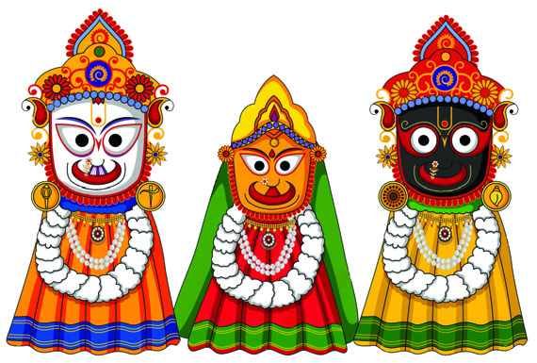
8. Why were temples built in Bengal?
A. Temples were built in Bengal because of the following reasons.
- i) Increase in religious faith.
- ii) Mosque had already been built.
- iii) Powerful people wanted to demonstrate their power and proclaim their piety.
- iv) ‘Low’ social groups also participated in the temple building.
- v) New economic opportunities to people also helped it temple setting up.
- vi) Support of Brahmanas to get idols placed in temples from huts.
- 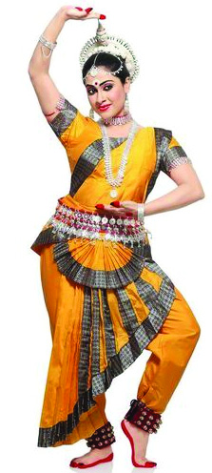
9. Describe the most important features of the culture of your region based on buildings, performing arts and painting.
A. Most important features of our culture and our region:
i) Hindu culture
ii) Celebrations of numerous festivals the year round.
iii) Worship of gods and goddesses.
iv) Bhajans and Kirtanas.
v) Paintings of gods and goddesses.
10. Do you use different languages for (a) speaking, (b) reading, (c) writing? Find out about one major composition in language that you use and discuss why you ﬁ nd it interesting.
A. i) Speaking:
ii) Reading:
iii) Writing:
- Do this yourself with the help of your history teacher.
11. Choose one state each from north, west, south, east and central India, for each of these, prepare a list of foods that are commonly consumed, highlighting any differences and similarities that you notice.
States | Foods | Similarities/Differences
North Haryana | Dal, Chapatis (of wheat) | Vegetatian
East West Bengal | Rice and Fish | Vegetarian + Non-Vegetarian
South Kerala | Rice and Fish | Vegetarian + Non-Vegetarian
Central India | Dal and Chapatis | Vegetarian + Non-Vegetarian
Punjab | Wheat and maize rotis and sarso ka saag, rajma chawal | Vegetarian

12. Choose another set of ﬁ ve states from each of these regions and prepare a list of clothes that are generally worn by women and men in each. Discuss your ﬁndings.

States | Clothes (Man) | Clothes (Woman)
North Panjab | Lungi, Kurta and Head gear | Salwar and Kameez
East Orissa | Dhoti, Kurta | Saree and Blouse
South Tamil Nadu | Kameez and Lungi/Tehmand | Saree, Blouse
Central Chhattisgarh | Kameez, Dhoti/Pant, Trousers | Saree, Blouse

